1.
a) Trap assisted recombination (also called Shockley-Read-Hall or SRH recombination). [5]
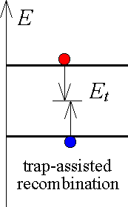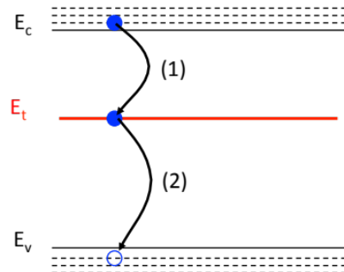
electrons and holes recombine via a trap level which is an energy level within the bandgap associated to impurities and defects in the semiconductor. They can recombine within the trap or via the trap.
Comments: most had this correct. The main error was to plot generation rather than recombination.
b) Impact ionisation
- [5]
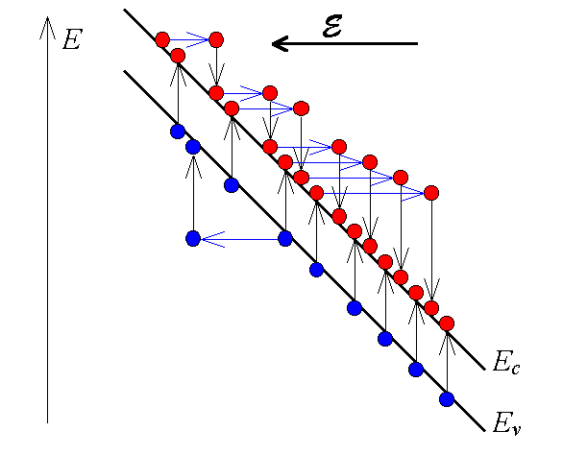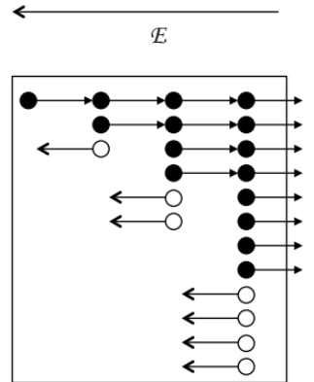
The diagram left illustrates impact ionisation on an energy band diagram, the one of the right within a material cross section.
Impact ionisation occurs under high electric field (high voltage per length). The carrier, electron or hole is accelerated by the high electric field, until it has high kinetic energy. Then it will collide, scatter, interact with a lattice atom, transfer its energy that then releases an electron-hole pair. The initial carrier together with the newly released pair will be accelerated by the field until their kinetic energy is sufficiently high that when interaction with an atom occurs, each can generate electron-hole pairs. Multiplier the initial number of e.g. electrons by 2^{N} electrons after N impact ionisation events.
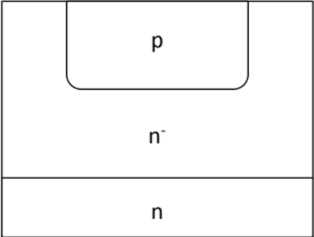
Comment: The main error is missing the key importance of the electric field and the resulting acceleration and the repetition of this. A serious problem was to relate this to carrier carrier scattering rather than carrier atom scattering. Some plots showed the Auger effect rather than impact ionisation.
- [5]
In order to reduce the probability for impact ionisation, the electric field must be kept small. This can be done by widening the drift region across which the reverse bias voltage occurs because the electric field = voltage/length. Therefore the devices are fabricated vertically to allow large lengths without consuming too much Si real estate.
The other aspect is to reduce the doping density such that the depletion region extends (widens) thus also reducing the electric field.
Very often just one effect given or no explanation for what it means.
c) for lifetime = based on exercise done in class & completely worked out in coursenotes [10]
Note: the following is a copy and paste from the note, however for the exam answer all subscript p must be changed into n.
Solving the switching problem: 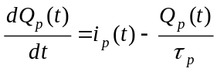
For 0 < t < t_{sd} we know that i_{p} remains constant at –I_{r}, thus:
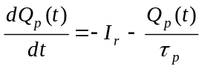
Separation of variables:
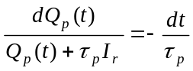
Integrate:
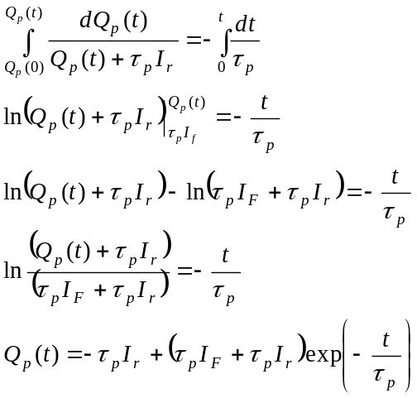
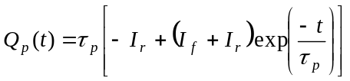
The storage delay time t_{sd} can then be extracted by stating that at t=t_{sd}, Q_{p}(t_{sd})=0. Thus:
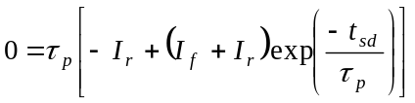
The storage delay time is then (under the assumption of quasi steady state) :
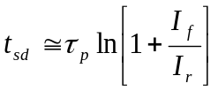
t_{sd} is given in Fig. 1.1(b): t_{sd} = 55.5 10⁻⁶ s. Since in the experiment (Fig. 1.1(a)) I_{F} = I_{R} the derived expression for t_{sd} becomes: t_{sd} = τ_{n} ln(2) thus τ_{n} = 8 10⁻⁵ s. [3]
Most students had it correct up to here. The approach below was often not carried out and the value of the diode voltage was often wrong, often the external voltage was used for the calculations.
The forward bias current is given in Fig. 1.1(b) to be i = 6.98 mA. This is the current that is effectively flowing through the diode. Since it is an n⁺p diode, the diode current is mainly determined by the electrons minority carrier diffusion current through the p-type region. The expression of the diode current destiny can be found from the formulae sheet.
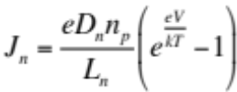 assuming V = V_{d} >> V_{T} and using $L_{n}=\sqrt{D_{n}τ_{n}}$ gives:
$I≈I_{n}=\frac{e{An}_{i}^{2}L_{n}}{τ_{n}N_{A}}exp\left(\frac{V_{d}}{V_{T}}\right)$ [3]
the diffusion length can be found from this expression
$L_{n}=\frac{I_{n}τ_{n}N_{A}}{e{An}_{i}^{2}exp\left(\frac{V_{d}}{V_{T}}\right)}$
Note that the voltage in this expression is the diode voltage, not the applied voltage. The diode voltage can be found from: V_{applied} = V_{d} + R I_{d} [1st year circuit analysis knowledge].
V_{d} = 7.55 V – 1000 Ω 6.98 10⁻³ A = 0.57 V [3]
Note that V_{d} is indeed >> V_{T}.
$L_{n}=\frac{6.98×{10}^{-3}×8×{10}^{-5}×{10}^{16}}{1.6×{10}^{-19}×1×{\left(1.45×{10}^{10}\right)}^{2}×exp\left(\frac{0.57}{0.026}\right)}=5×{10}^{-2}cm$ [1]
d) [5]
This is because the BJT was in oversaturation. This means that the base current was high such that the transistor goes into oversaturation because the output current is clamped by the load. In that case, the base current builds up a large stored charge in the base supplied by the 2 forward biased junctions (EB and BC). See figure. When the base voltage goes into reverse bias, first the additional base charge needs to be removed before the forward bias on the BC junction can get to zero and then turn reverse. It is at that moment (V_{BC} = 0) that we reach t=t_{a} and i_{c} can drop together with i_{b}.
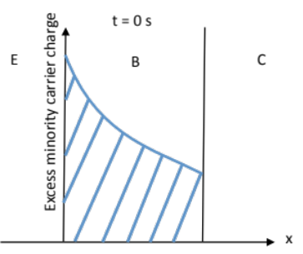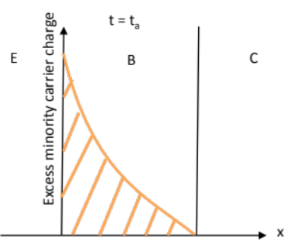
region (A) in fig. 1.2 onset of region (B) in fig. 1.2
The charge difference between the blue plot and the orange plot needs to be removed before the BC voltage can go to reverse bias and i_{c} = β i_{b} is followed again.
The main error here was not drawing the appropriate plots of excess minority carrier concentration, or any relevant plot that can demonstrate the same argument.

2.

a) In general no problem.
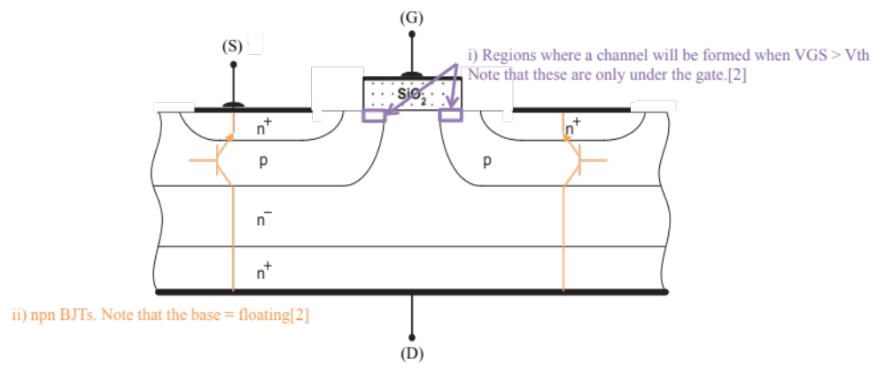
- (1) The gate overlap with the p-type region is not sufficient to invert a channel that connects the source via the channel to the drain. Thus the transistor is will be difficult or even impossible to switch on.
(2) The source contacts must overlap the p-type region in order to avoid the base of the parasitic BJTs to float and thus have any possible voltage depending on electrical noise that might switch it on. Connecting the p-region to the source connects it to the emitter, making I_{B} = 0. [4]
- . [2]
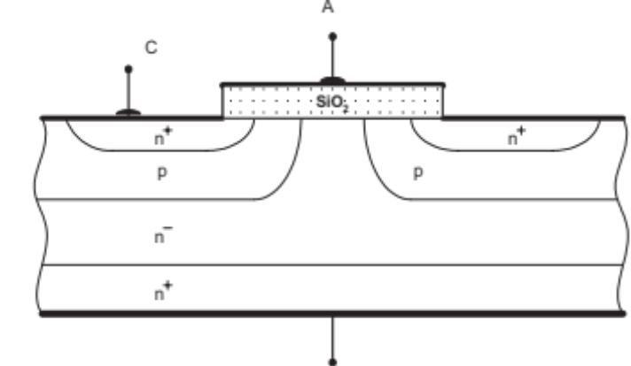

b)
- [5]
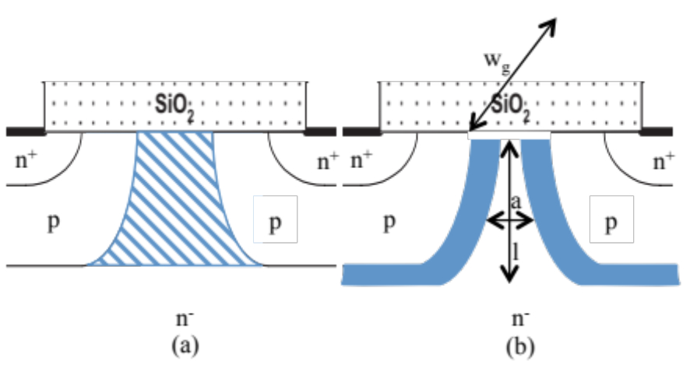
Figure (a) indicates the region that is called the JFET region. The resistance of that region is determined by the width of the n⁻ region between the p-doped region and this is controlled by the depletion width around the pn⁻ junction. When the drain voltage is positive, then this junction is reverse biased and the depletion region will extend in the lowest doped area. See figure (b). Thus the remaining undepleted width between the two depletion regions is becoming narrower. The resistance is: $R=\frac{ρ×l}{a×w_{g}}$ with w_{g} the gate width. The more depletion V_{DS} increases, the smaller a the higher the resistance R.
Comment: very often there was no explanation on how the depletion width is related to the VDS and thus extending, or it was left vague on whether depletion is due to VDS or VGS. In addition the justification for an increased resistance in view of the width of the channel through which the current has to flow was not given.
- [5]
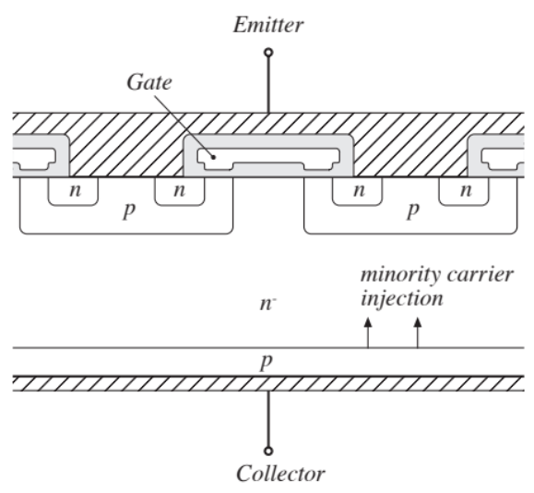
The IGBT differs from the DMOS in that the bottom contact is p-type. When the BJT is on the pn⁻ junction near the collector contact is forward biased (remember that the naming of the contacts in this structure is misleading and is only base on historical arguments). The forward bias will inject minority carriers in a lowly doped region, thus very soon this can be seen as high injection condition. In high injection condition the majority carrier concentration has to increase to compensate the large minority carrier concentration effectively reducing the resistance of the n⁻ layer. This is called conductivity modulation.
Very often the importance of the lowly doped region on how easy it is to hit high level injection was missed in the explanation. Answering conduction modulation without further explanation is not enough. Conduction modulation needs to be explained.

